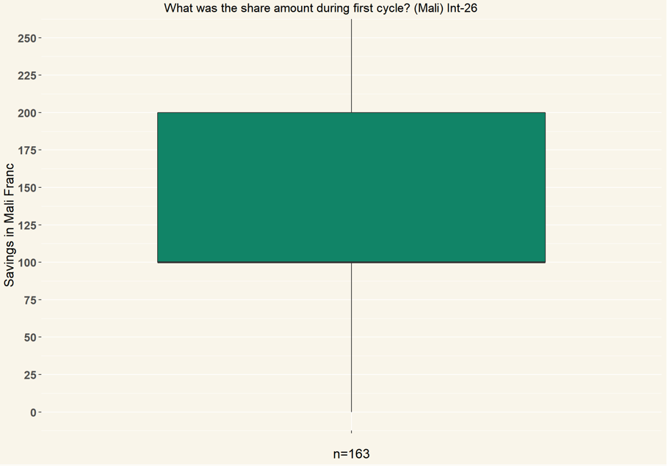

Please change the title to “What was the fixed savings amount during the first cycle?”

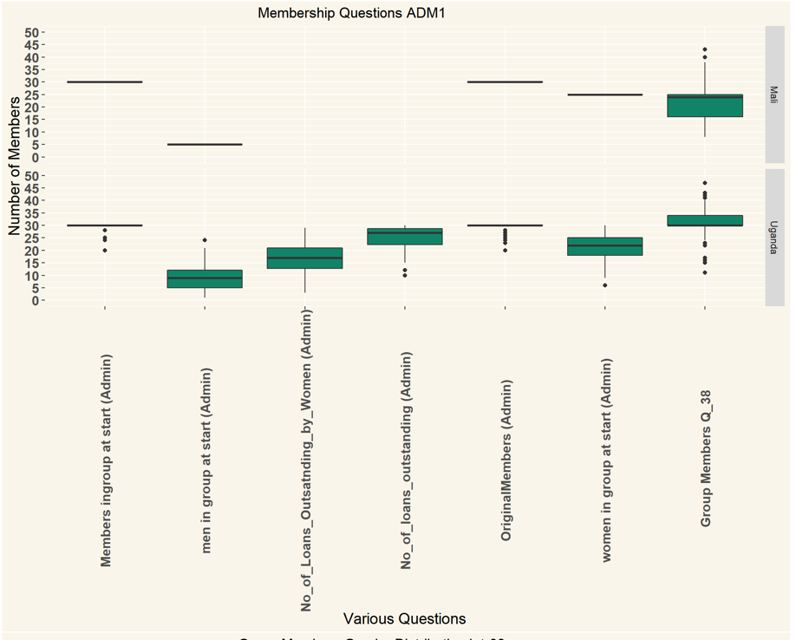

As mentioned earlier, please take the “No of loans outstanding by women in first cycle” and “Total no of loans outstanding in first cycle“ out of this graph and make a separate graph.

Order the remaining data logically, with clearly indicating which data is from “first cycle” and which is from current info.

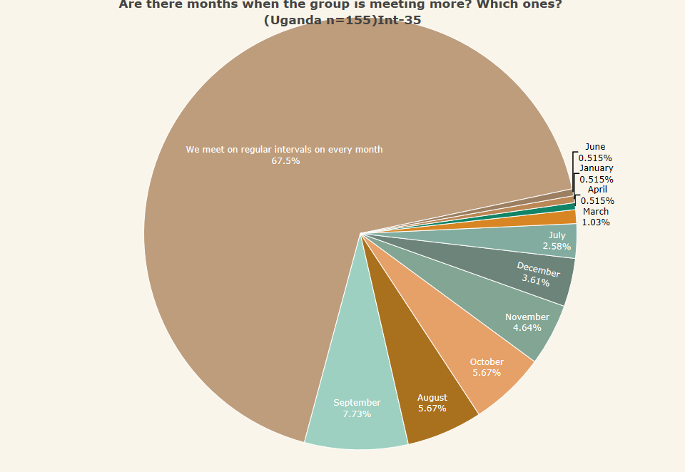

Could you place the months in chronological sequence? Jan, Feb, Mar, etc.

This also applies to the other Int-35, Int-36 questions.

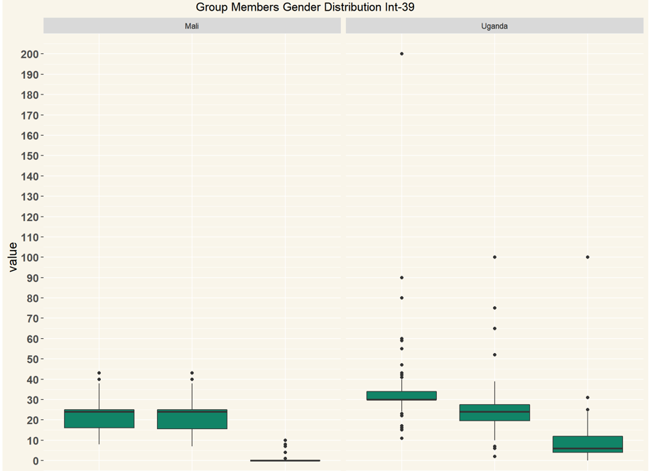

It is a very nice one, but I can’t see anymore which one is total, which is womenand which is men. (I think the far left is total, middle is women, right is men. Correct? But still, please label it.

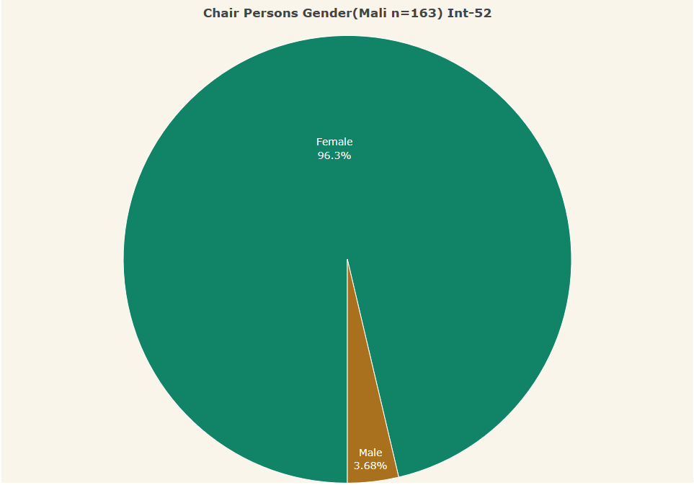

The title should be changed to “respondent’s gender”